**Pratice Making A Framework** **Proximity Sensor**

*Damar Lintang Priyatama*

*Fakultas Vokasi, Universitas Brawijaya*

*Email:* [*damarpriya138@gmail.com*](mailto:damarpriya138@gmail.com)

**Abstract**

This project demonstrates the use of an ultrasonic distance sensor, commonly known as an HC-SR04, to measure distances in both centimeters and inches. The sensor is interfaced with an ESP32 microcontroller, with the triggering pin connected to pin 5 and the echo pin connected to pin 18. The system works by emitting a sound wave from the trigger pin, which then bounces off an object and returns to the echo pin. By measuring the time taken for the sound wave to travel, the microcontroller calculates the distance between the sensor and the object. The distance is computed in centimeters, and can also be converted into inches for alternative units of measurement. The measured distance is output in real-time to the serial monitor for visualization. The experiment showcases the basic principles of ultrasonic distance measurement, sensor interfacing, and real-time data processing with the ESP32, providing a foundation for applications such as obstacle detection, distance sensing, and automation systems.

*Keywords—* *Ultrasonic sensor, distance measurement, ESP3, IoT, automation systems.*

**1. Introduction**

**1.1 Background**

This project explores the integration of the HC-SR04 ultrasonic sensor with the ESP32 microcontroller for accurate and real-time distance measurement. The setup utilizes basic principles of sound wave propagation to measure distance in centimeters, with the possibility of converting the results into inches. The collected data is then displayed on the serial monitor, making it accessible for further analysis or integration into larger systems. This background highlights the practicality and wide-ranging applications of ultrasonic sensors in embedded systems and IoT, offering a simple yet powerful solution for precise distance measurement in various contexts.

**1.2 Purpose Experience**  
The purpose of this experiment is to demonstrate the integration and functionality of an ultrasonic distance sensor (HC-SR04) with the ESP32 microcontroller for real-time distance measurement. Through this experiment, the objective is to explore how sound waves can be used to determine the distance between the sensor and an object, leveraging the time-of-flight principle. The experiment aims to provide a hands-on understanding of how to interface the HC-SR04 sensor with the ESP32, using the trigger and echo pins to measure the time taken for the ultrasonic pulse to travel to an object and return.

**2. Methodology**

**2.1 Tools & Materials**

-Laptop Asus

-Vscode

-Arduino IDE

-ESP32 Board Support

**2.2 Implementation Steps**

-Open Arduino IDE and choose ESP32 for Proximity Sensor

-Arrange the ESP32 framework by adding HC-SR04 Ultrasonic Distance Sensor

-After that connect the cables according to int and GND

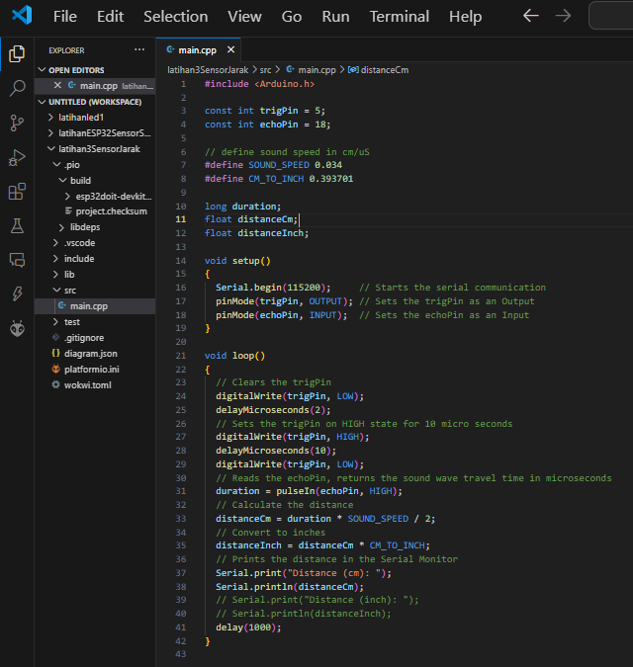-Type the code like this in main.c

-If the results of the HC-SR04 can can be adjusted by sliding according to the task, then you have finished completing the Proximity Sensor

**3. Results and Discussion**

**3.1 Experimental Results**

* 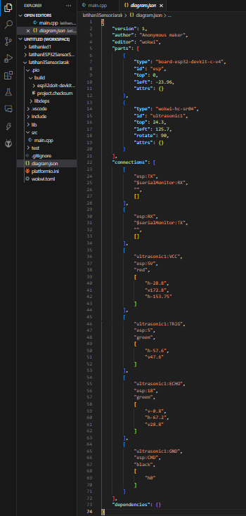diagram.json

* 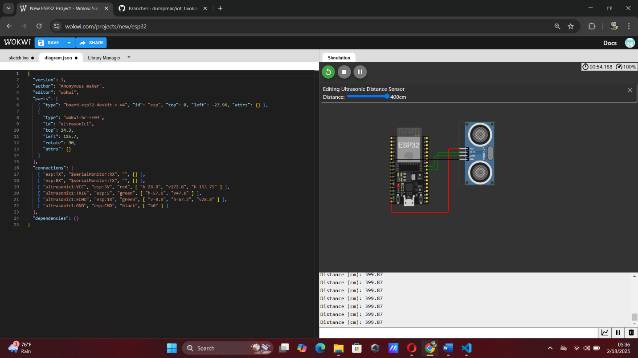Result Proximity Sensor from wokwi.com
* 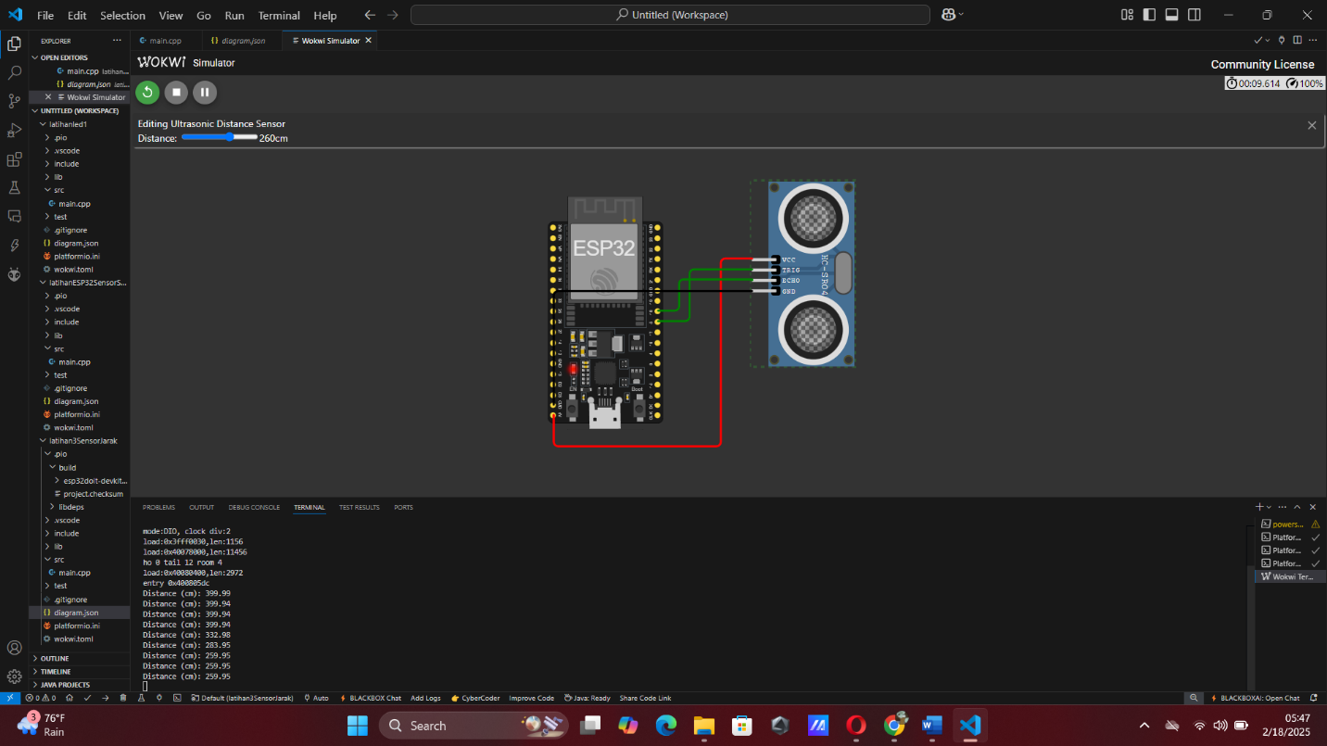Result Proximity Sensor from wokwi.com